Reprioritizing Your Priorities Worksheet

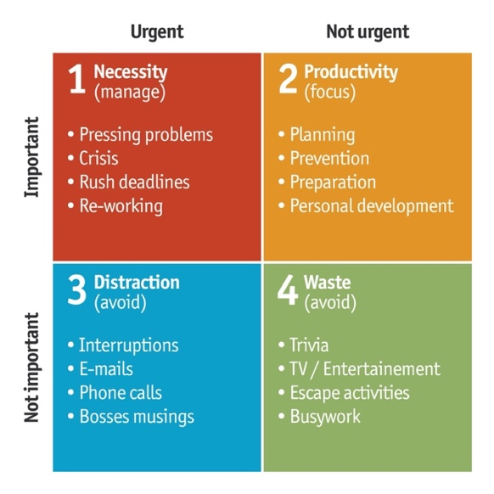
A Tool for Realignment: The Eisenhower Matrix
Use this framework to categorize your current tasks.

Many of us operate in the "Urgent & Not Important" quadrant — dealing with interruptions and busy work. This worksheet aims to help you shift into the "Not Urgent & Important" quadrant — the space where discipleship and relationship-building happen.

Fill in the four quadrants as honestly as possible.
Finish one task from each quadrant this week.

 | URGENT | NOT URGENT
 | Do It | Schedule It
IMPORTANT
 | Delegate It | Eliminate It
NOT IMPORTANT

